 | TO: | [Please insert Supplier]
 | Address 1:
 | Address 2:
 | City:
 | Country:
 | Phone #:
 | E-mail:

 | FROM: | Tarna Rom
 | Address 1: | Str. Gh.Asachi 32
 | Address 2:
 | City: | Chisinau
 | Country: | Moldova
 | Phone #:  Email: | 079730876  tarna.rom.pr@gmail.com
 | E-mail:

The Non-Governmental Organization "Union of Young Roma from the Republic of Moldova" TARNA ROM is excited to invite your company to participate in our Open Tender(OT) for the Equip the Comunity Center for Roma Mediator for podcast development OT No. TARNA/MOL/2026/OT/SUPP0007

Request for Quotation Details
RFQ #: | TARNA/MOL/2026/OT/SUPP0007 | Currency of Bid (3-letter code): | MDL
RFQ Issuing Date: | 06.07.2026 | Bid Validity Period (days): | 45
RFQ Closing Date: | 20.07.2026 | Required Delivery Date: | July 2026
RFQ Closing Time: | EOB | Required Delivery Destination: | Chisinau, Moldova
Questions to the RFQ | tarna.rom.pr@gmail.com | Required Delivery Terms: | Maximum in 25 days after placing the order
For Tarna Rom to Complete/Pentru Tarna Rom |  |  | For Supplier to Complete/Pentru Furnizor
Item # | Description | Quantity Required | Description – Brand and model | Unit price with VAT | Unit price with VAT | Warranty period
1 | Laptop for video editing 16" | IPS | 165 Hz | 16 GB | 512 GB | Core i7 14650HX | NVIDIA GeForce RTX 5050 | 8 Gb GDDR7 | 1
2 | Main camera (mirrorless) + obiectiv pentru video bloging si podcast. Procesor de imagineDIGIC X  Dimensiunea / tipul ecranului7.5 cm (3.0") Clear View LCD II (1,62k de puncte)  Dimensiunea senzoruluiCadru complet (36 x 24 mm)  Raport de aspect1  Pixeli Efectivi24,2 MPix  Dimensiunea imaginii (max.)6000x4000  Conexiune fără fir5 / 2.4 GHz Wi-Fi 5 (802.11ac) | 2
3 | Professional tripod - Descriere scurtă:  Tipul capului de trepied  Cap trepied de minge  Rotația coloanei centrale  360 ° în orice direcție  Materiale  Aluminiu  Înălțimea maximă  182,8 cm  Înălțimea minimă  26,6 cm  Greutate maximă de încărcare  25 kg  Greutate  0,64 kg  Culoare  Negru | 4
4 | Lighting kit (LED panels)  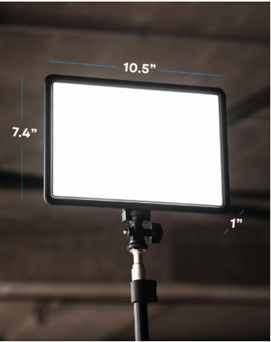 | 4
5 | Softbox 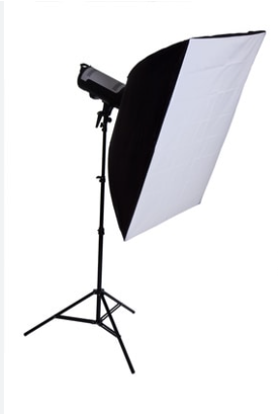 | 2
6 | Extra LED light sticks 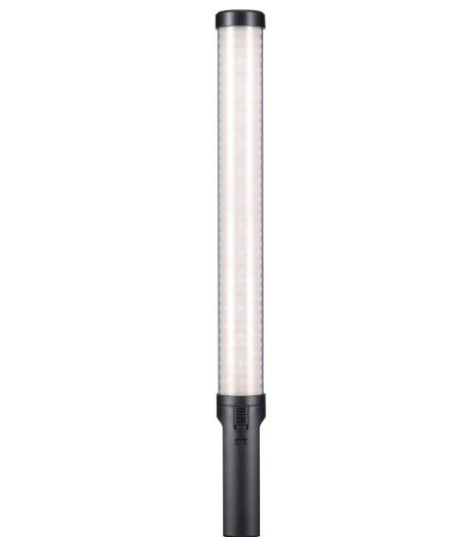 | 2
7 | Microphone on tripod 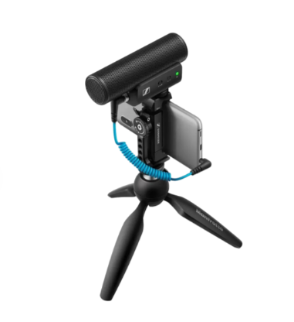 Diapazon frecvențe50 – 20 000 Hz  Tipul de conexiune - Cu fir  Sursă de alimentare  Baterie Integrată | 3
8 | Lavalier microphones  Diapazon frecvențe20 - 20000 Hz  Tipul de conexiuneFără fir  Raza semnal maximă300 m  Sursă de alimentareBaterie reîncărcabilă  Durata de viață a bateriei30 Ore  Capacitatea bateriei receptorului240 mAh  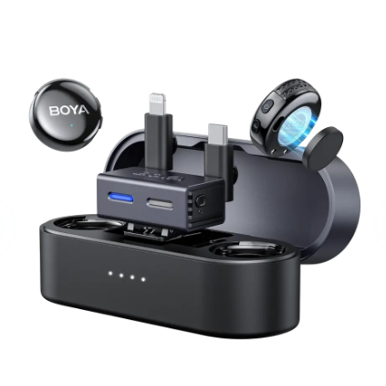 | 2
9 | Backdrops -  | 1
10 | Cables, adapters, chargers | If needed
11 | HDD storage(2 TB) | 1

NOTE for the Suppliers:

TARNA ROM plans to procure professional equipment for podcast production.
If a supplier does not have the exact equipment requested, they may offer an equivalent or the closest available alternative, provided that all the minimum required technical specifications are met or exceeded.
The images included in the technical specifications are for illustrative purposes only and are intended solely to demonstrate the type of equipment required. They do not indicate or imply any preference for a specific brand or manufacturer.
Evaluation Criteria:
- Price – 40%
- Compliance with the required technical specifications – 20%
- Delivery time – 20%
- Warranty period – 20%
TARNA ROM reserves the right to award the contract to more than one supplier if:
- a single supplier is unable to provide all requested items; or
- a supplier submits an unreasonably high price for one or more items.
In such cases, TARNA ROM may split the award among multiple suppliers in order to ensure the best overall value for the project.

Delivery Lead Time (from receipt of Tarna Rom Purchase Order): _ ____________ (Calendar) days

Bid Validity Period(minimum 45 days): ____________ ((Calendar) days

I certify that I have read and understood the Tarna Rom Code of Conduct for the Procurement of Goods and the Tarna Rom Contract Annex. I further certify that the above-mentioned company has not engaged in corrupt, fraudulent, collusive, or coercive practices in competing for, or in executing, any Contracts.

Signed: __________________________ Position: ______________________

Print Name: ________________________ Date: _______________________
Please stamp this Bid Form with your Company Stamp

Open Tender INSTRUCTIONS

Submission of Bid
You must submit one original of the RFQ Bid Form in a sealed envelope, clearly marked with the RFQ number and the Bidders name. The bid can be delivered directly to the tender box, mailed, or delivered by courier services, or alternatively send by email to the following dedicated, secure & controlled email address: tarna.rom.pr@gmail.com

Phone number
+373 79 730876

The following mandatory documents with the compulsory Open Tender Bid Form are to be submitted:

- RFQ Form - must be saved in PDF format, signed and stamp by authorized company representative
- Majority Owner’s ID copy (Optional)
- Company’s Registration Certificate issued by the relevant state authority (Extras)
- Tarna Rom Code of Conduct (signed and stamped)
- Tarna Rom Annex to Contract (signed and stamped)

Evaluation of Bids
All Bids received and accepted will be evaluated on a ‘line item’ basis as follows:

  - Administrative Evaluation: Evaluated to ensure compliance with all the RFQ requirements and to ensure that all Bids and calculations are readable and acceptable.

  - Technical Evaluation: All Bids received will undergo a Technical Evaluation based on ‘best value for money’. Bids that comply with the requested items, specifications, and delivery conditions will be classed as ‘responsive’ (acceptable). Only Bids classed as ‘responsive’ (acceptable) will progress onto the ‘Financial Evaluation’. ‘Non-responsive’ bids (not-acceptable Bids) will no longer be under consideration at this stage.

  - Financial Evaluation: All ‘Responsive’ Bids will undergo a Financial Evaluation

Contract Award
Under the ‘best value for money’ principle, Tarna Rom will award the contract to the ‘lowest responsive bid’ except where other considerations are warranted. These other considerations can be – total cost of ownership; cost of on-going consumables; price vs warranty; quality vs price.

RFQ Enquires
All enquires and questions should be addressed to the email given in the RFQ Detail’s section! All Q&A’s will be shared with all invited suppliers.

Alexandr Pruglo
Supply Chain Officer 06.07.2026

