 | TO: | [Please insert Supplier]
 | Address 1:
 | Address 2:
 | City:
 | Country:
 | Phone #:
 | E-mail:

 | FROM: | Tarna Rom
 | Address 1: | Str. Gh.Asachi 32
 | Address 2:
 | City: | Chisinau
 | Country: | Moldova
 | Phone #:  Email: | 079730876  tarna.rom.pr@gmail.com
 | E-mail:

The Non-Governmental Organization "Union of Young Roma from the Republic of Moldova" TARNA ROM is excited to invite your company to participate in our Open Tender(OT) for the Equip the Comunity Center for Roma Mediator from Soroca and Otaci OT No. TARNA/MOL/2026/OT/SUPP0008

Request for Quotation Details
RFQ #: | TARNA/MOL/2026/OT/SUPP0007 | Currency of Bid (3-letter code): | MDL
RFQ Issuing Date: | 31.07.2026 | Bid Validity Period (days): | 45
RFQ Closing Date: | 04.08.2026 | Required Delivery Date: | August 2026
RFQ Closing Time: | EOB | Required Delivery Destination: | Chisinau, Moldova
Questions to the RFQ | tarna.rom.pr@gmail.com | Required Delivery Terms: | Maximum in 10 days after placing the order
For Tarna Rom to Complete/Pentru Tarna Rom |  |  | For Supplier to Complete/Pentru Furnizor
Item # | Description | Quantity Required | Description – Brand and model | Unit price without VAT | Unit price with VAT
LOT 2
1 | Curtains or blinds with installation (around 200*170) 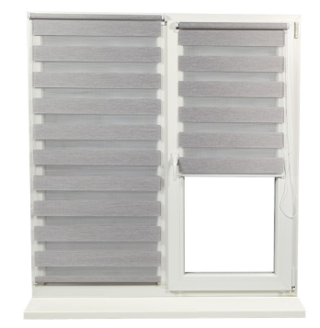 | 1 pcs
2 | Wall Painting (eco-friendly paint) - refers to painting the walls with one coat of eco-friendly paint | Per 1 m2
3 | Wall mural (child-friendly) around 2m × 3m – includes creating and painting a child-friendly mural directly on the wall, with a total approximate size of 2m × 3m.  Mural examples  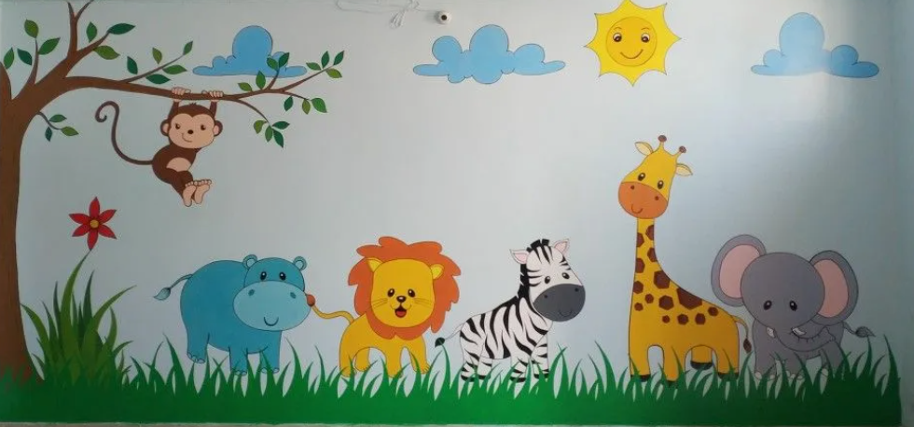  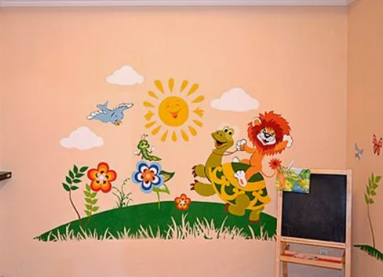   | 1

NOTE for the Suppliers:

The Public Association TARNA ROM is seeking a qualified supplier to equip two activity spaces located in Soroca and Otaci for the organization of interactive games, educational activities, and information sessions for children.

The scope of this tender includes works at two locations: Soroca and Otaci. The selected supplier shall perform the required works in both the city of Soroca and the city of Otaci.

Suppliers may offer prices for the complete list of items or submit separate prices for individual items. TARNA ROM may conclude a contract with one supplier covering all items or with several suppliers for different items, based on the best value offer received.

If a supplier is unable to provide the exact products specified in the technical specifications, they may propose the closest equivalent products, provided that all minimum required technical specifications are fully met or exceeded. The images included in the technical specifications are for illustrative purposes only and are intended solely to demonstrate the type of equipment required. They do not indicate or imply any preference for a specific brand or manufacturer.

TARNA ROM reserves the right to request product samples from shortlisted or selected suppliers for quality verification before awarding the contract.
Evaluation Criteria:
- Price – 50%
- Compliance with the required technical specifications – 30%
- Delivery lead time – 20%
TARNA ROM reserves the right to award the contract to more than one supplier if:
- a single supplier is unable to provide all requested items; or
- a supplier submits an unreasonably high price for one or more items.
In such cases, TARNA ROM may split the award among multiple suppliers in order to ensure the best overall value for the project.
Both legal entities and natural persons are eligible to participate in this tender.

Delivery Lead Time (from receipt of Tarna Rom Purchase Order): _ ____________ (Calendar) days

Bid Validity Period(minimum 45 days): ____________ ((Calendar) days

I certify that I have read and understood the Tarna Rom Code of Conduct for the Procurement of Goods and the Tarna Rom Contract Annex. I further certify that the above-mentioned company has not engaged in corrupt, fraudulent, collusive, or coercive practices in competing for, or in executing, any Contracts.

Signed: __________________________ Position: ______________________

Print Name: ________________________ Date: _______________________
Please stamp this Bid Form with your Company Stamp

Open Tender INSTRUCTIONS

Submission of Bid
You must submit one original of the RFQ Bid Form in a sealed envelope, clearly marked with the RFQ number and the Bidders name. The bid can be delivered directly to the tender box, mailed, or delivered by courier services, or alternatively send by email to the following dedicated, secure & controlled email address: tarna.rom.pr@gmail.com

Phone number
+373 79 730876

The following mandatory documents with the compulsory Open Tender Bid Form are to be submitted:

- RFQ Form - must be saved in PDF format, signed and stamp by authorized company representative
- Majority Owner’s ID copy (Optional)
- Company’s Registration Certificate issued by the relevant state authority (Extras)
- Tarna Rom Code of Conduct (signed and stamped)
- Tarna Rom Annex to Contract (signed and stamped)

Evaluation of Bids
All Bids received and accepted will be evaluated on a ‘line item’ basis as follows:

  - Administrative Evaluation: Evaluated to ensure compliance with all the RFQ requirements and to ensure that all Bids and calculations are readable and acceptable.

  - Technical Evaluation: All Bids received will undergo a Technical Evaluation based on ‘best value for money’. Bids that comply with the requested items, specifications, and delivery conditions will be classed as ‘responsive’ (acceptable). Only Bids classed as ‘responsive’ (acceptable) will progress onto the ‘Financial Evaluation’. ‘Non-responsive’ bids (not-acceptable Bids) will no longer be under consideration at this stage.

  - Financial Evaluation: All ‘Responsive’ Bids will undergo a Financial Evaluation

Contract Award
Under the ‘best value for money’ principle, Tarna Rom will award the contract to the ‘lowest responsive bid’ except where other considerations are warranted. These other considerations can be – total cost of ownership; cost of on-going consumables; price vs warranty; quality vs price.

RFQ Enquires
All enquires and questions should be addressed to the email given in the RFQ Detail’s section! All Q&A’s will be shared with all invited suppliers.

Alexandr Pruglo
Supply Chain Officer 31.07.2026

